Report
Of
Topic
YOUTH SENSITISATION THROUGH SOCIAL ACTION

Submitted
To
School of Computer Science and Engineering
IILM University, Greater Noida, U.P.

In partial fulfilment of the requirement of degree of
B.Tech CSE



By
Roll Number of Student: 25SCS1003005085
Name of Student: ANSH Chaudhary
Batch: 2025-29
Internship Organisation: Relief Mission Foundation
Mode of Internship: VIRTUAL
Internship Period: 20 July 2026 – 20 Sept. 2026 (Month 1 of 2-Month Tenure)

2026-27

CANDIDATE’S DECLARATION

I, ANSH CHAUDHARY, do hereby declare that the internship report titled “Youth Sensitisation through Social Action: Understanding Social Issues and the Role of an NGO in Responding to Them” has been completed by me to fulfil the requirement for the award of the degree of Bachelor of Technology in Computer Science and Engineering. All the references have been quoted and I have not taken as such any material from any other source. I affirm to you that this report is my own and has not been submitted to any other institute for any degree/diploma requirement and further I shall be solely responsible for any kind of copyright violation in this regard.
The report is based on my learning, active execution of Human Resources (HR) responsibilities, digital campaign management, remote coordination, and reflective observation during the first month (01 July 2026 to 31 July 2026) of my two-month virtual internship with Relief Mission Foundation. All supporting organizational registration documents and communication proofs have been appropriately incorporated as annexures.

Student Name: Ansh Chaudhary
Roll No.: 25SCS1003005085

ACKNOWLEDGEMENT

I am using this opportunity to express my gratitude to everyone who supported me throughout the Internship Program. I am thankful for their aspiring guidance, invaluably constructive criticism, and friendly advice during this work. I am sincerely grateful to them for sharing their truthful and illuminating views on a number of issues related to this work.
I extend my heartfelt gratitude to Relief Mission Foundation for providing me with the opportunity to serve as an HR Intern under its social action and talent management initiative. I am deeply appreciative of the foundation's leadership, mentorship, and administrative team for their continuous guidance, professional feedback, and trust in delegating core recruitment, intern supervision, and content creation responsibilities during the first month of my two-month internship tenure.
I express my gratitude to my parents for their blessings and constant support throughout the duration of this internship.
Furthermore, I extend my sincere thanks to the faculty members and internship coordinators at the School of Computer Science and Engineering, IILM University, Greater Noida, for encouraging interdisciplinary exposure and enabling engineering students to apply technical, organizational, and managerial skills within non-profit frameworks.

Student Name: Ansh Chaudhary
Roll No.: 25SCS1003005085

Chapter No. | Chapter Name | Page Nos.
1. | Candidate’s Declaration | i
2. | Acknowledgement | ii
3. | Internship Completion Certificate / Communication Proof | iii
4. | Project Description | 1
4.1 | Introduction | 1
4.2 | Organization Profile | 2
4.3 | Problem Statement | 3
4.4 | Project Objectives | 4
4.5 | Scope of the Project | 4
4.6 | Technologies and Tools Used | 5
4.7 | System Architecture / HR Workflow | 5
4.8 | Methodology | 6
4.9 | Virtual Internship Implementation & Human Resource Operations | 6
4.10 | Activities and Work Performed Virtually | 7
4.11 | Areas of Social Issues Covered | 8
4.12 | My Role as an HR Intern | 8
4.13 | Expected Outcomes | 9
4.14 | Learning Outcomes | 9
4.15 | Challenges and Observations | 9
4.16 | Recommendations | 10
4.17 | Conclusion | 10
4.18 | Offer Letter and Communication Proof | 11-12
5. | Bibliography / References | 13-14

4. PROJECT DESCRIPTION
4.1 Introduction
As an undergraduate Computer Science and Engineering student at IILM University, Greater Noida, engaging in a 2-month virtual internship with Relief Mission Foundation in an HR (Human Resources) role provided a powerful platform to observe how technology, structured organizational management, and social advocacy merge. This report documents the operational execution, empirical learning, and system workflows completed during the first month of my two-month internship tenure (01 July 2026 – 31 July 2026).
The main focus of this internship is to bridge the gap between technical problem-solving and non-profit human capital management. In modern non-governmental organizations (NGOs), non-profit outreach relies heavily on effective talent acquisition, digital outreach, clear communication channels, and systematic tracking of intern workflows.
Operating virtually as an HR Intern required deploying digital tools—ranging from spreadsheet analytics for tracking applicants to graphic design software for job announcements and recruitment branding across professional platforms like LinkedIn. By taking ownership of hiring cycles, candidate screening, interview scheduling, graphic design for vacancy banners, active platform engagement, and the daily supervision of onboarded interns, I was able to observe firsthand how structured HR practices directly support an NGO's mission to address social challenges.

1.
4.2 Organization Profile
Relief Mission Foundation is a registered non-profit Section 8 charitable company incorporated under the Companies Act, 2013 (18 of 2013) by the Central Registration Centre, Ministry of Corporate Affairs, Government of India.
- Date of Incorporation: June 18, 2021
- Corporate Identity Number (CIN): U85300RJ2021NPL075422
- Section 8 Licence Number: 126369
- Permanent Account Number (PAN): AALCR07121
- Registered Office Address: C/o Manoj Agg., Behind Shekhawat Nursing, Ward No. 15, Mohalla Bachhadi, Kotputli, Jaipur, Rajasthan, India – 303108
- Core Operational Philosophy: Relief Mission Foundation was established on the firm belief that sustainable societal change begins with compassion, collective effort, and empowering vulnerable populations. Situated operationally out of Jaipur, Rajasthan, the foundation works closely with underprivileged children and women, focusing on fundamental human rights including food security, proper sanitation, clean environments, and educational support.
The organization leverages digital channels, virtual internship drives, and professional networks like LinkedIn ("Relief Mission Foundation: Overview | LinkedIn") to attract youth volunteers, build public awareness, and secure resources for community development initiatives.

2

4.3 Problem Statement
Non-governmental organizations working in child welfare, women empowerment, and community relief often face operational challenges in talent acquisition, volunteer retention, and workflow management. Unlike commercial corporate entities with dedicated HR infrastructure, NGOs depend heavily on remote volunteers and intern cohorts to carry out campaign outreach, content creation, and administrative support.
The core problem addressed during this internship project centers on the lack of standardized, technology-driven human resource workflows within virtual NGO operations. Key operational bottlenecks include:
- Recruitment Inefficiencies: Fragmented applicant sourcing and delayed candidate response times due to unstructured communication channels.
- Branding & Outreach Disconnect: Ineffective visual branding of open volunteer positions, resulting in poor conversion rates from job postings on professional networks like LinkedIn.
- Tracking & Candidate Evaluation Gaps: Lack of centralized record-keeping for interview schedules, screening metrics, and candidate progress tracking.
- Post-Onboarding Supervision Deficits: Inconsistent daily task tracking and supervision for remote interns, leading to reduced accountability and variable deliverable quality.
Addressing these challenges required establishing structured HR management pipelines using digital platforms, data organization, visual design toolsets, and continuous multi-channel engagement.
3
4.4 Project Objectives
- To design and deploy standardized recruitment and screening workflows for remote intern hiring drives at Relief Mission Foundation.
- To leverage professional networking platforms (specifically LinkedIn) and instant messaging channels (WhatsApp) for candidate communication and talent pipeline management.
- To utilize digital graphic design tools like Canva to craft visually appealing vacancy posters, recruitment announcements, and brand assets.
- To maintain centralized candidate databases and selection logs using spreadsheet software (Microsoft Excel / Google Sheets).
- To coordinate, schedule, and conduct virtual interview sessions for prospective interns across multiple functional roles.
- To supervise, monitor, and evaluate the daily performance and work deliverables of onboarded interns.
- To connect computer science data management principles with non-profit organizational dynamics to improve operational efficiency.

4.5 Scope of the Project
The project scope encompasses human resource management, digital recruitment marketing, intern workflow coordination, and organizational communication executed during the first month of the two-month internship tenure. The core functional domains covered include:
- Talent Sourcing & Recruitment Marketing: Conceptualizing, designing, and publishing professional vacancy announcements on LinkedIn and partner channels.
- Graphic Content Creation: Designing poster graphics, role requirements flyers, and campaign banners using Canva.
- Data Management & Tracking: Building structured Excel workbooks to record applicant credentials, screening statuses, interview schedules, and selection outcomes.
- Candidate Engagement & Interview Coordination: Managing primary screening communications, sending interview invites, conducting remote interviews, and handling inquiries via WhatsApp and email.
- Team Supervision & Onboarding: Overseeing active intern batches, delegating daily project tasks, reviewing submissions, and resolving workflow blockers.

4

4.6 Technologies and Tools Used
Executing the HR and digital management operations virtually required leveraging several software applications, data management tools, and online platforms:
- Professional Networking & Hiring: LinkedIn ("Relief Mission Foundation: Overview | LinkedIn") for job posting, talent sourcing, organization updates, and candidate profile verification.
- Real-time Communication: WhatsApp Business and Email for rapid candidate screening, interview dispatch, team coordination, and daily task updates.
- Data Synthesis & Tracking: Microsoft Excel and Google Sheets for maintaining applicant databases, interview scorecards, and intern task compliance matrices.
- Graphic Design & Branding: Canva for visual poster creation, designing social media vacancy cards, and maintaining brand identity guidelines.
- Video Conferencing: Google Meet / Zoom for conducting candidate interviews and holding virtual team check-in sessions.
- Documentation & Reporting: Microsoft Word and Google Docs for drafting job descriptions (JDs), interview guidelines, and formal internship progress reports

4.7 System Architecture / HR Workflow
The operational architecture of the Human Resource workflow implemented at Relief Mission Foundation follows a systematic, technology-assisted talent acquisition and team management lifecycle:
- Requirement Analysis: Identifying staffing needs across foundation initiatives (e.g., social media, fundraising, graphic design, content writing).
- Visual Asset Generation: Creating targeted recruitment posters and flyers in Canva.
- Multi-Channel Broadcast: Distributing opportunity listings on LinkedIn and WhatsApp groups, maintaining high responsiveness.
- Data Structuring: Filtering incoming applications and entering details into a structured Excel master database.
- Interview Management: Scheduling interview slots, dispatching video links, and evaluating candidates against established rubrics.
- Intern Supervision: Assigning daily deliverables to selected interns, monitoring deadline compliance, and maintaining project output quality.

5

4.8 Methodology
The operational methodology was structured into five distinct phases executed over the first month of the internship:
- Phase 1: Need Assessment & JD Standardization: Collaborating with foundation leaders to define job descriptions, required skill sets, and tenure expectations for incoming intern batches.
- Phase 2: Visual Branding & Outreach Campaigning: Utilizing Canva to design customized promotional assets for LinkedIn and social channels to maximize visibility and application volume.
- Phase 3: Database Construction & Candidate Screening: Setting up Excel tracking sheets to organize applicant profiles, track candidate communication, and log interview outcomes.
- Phase 4: Remote Selection & Onboarding: Conducting virtual interviews, evaluating candidate soft skills and domain competencies, issuing onboarding materials, and configuring WhatsApp workgroups.
- Phase 5: Supervisory Monitoring & Process Optimization: Establishing daily check-ins to monitor active intern deliverables, reviewing output quality, providing constructive feedback, and refining recruitment strategies for upcoming cycles.

4.9 Virtual Internship Implementation & Human Resource Operations
Executing HR responsibilities virtually demanded strong self-discipline, time management, and continuous multi-channel engagement. The virtual model required clear communication protocols to replace physical workplace interactions.
Key elements of the virtual HR implementation included:
- Continuous Digital Presence: Maintaining active availability on LinkedIn and WhatsApp to promptly respond to applicant inquiries, resolve intern blockers, and manage foundation communications.
- Structured Data Repository: Maintaining synchronized spreadsheet databases in Microsoft Excel to eliminate candidate drop-offs and track intern progress.
- Remote Leadership & Accountability: Managing a cohort of remote interns, establishing clear task guidelines, enforcing deadlines, and encouraging team collaboration through structured digital check-ins.

6

4.10 Activities and Work Performed Virtually
During the first month of my two-month tenure (01 July 2026 – 31 July 2026), my primary responsibilities focused on HR operations, talent acquisition, media design, and team supervision:
- Designing Vacancy Posters using Canva: Created visual recruitment assets, promotional banners, and social media posts highlighting active internship openings at Relief Mission Foundation.
- LinkedIn Channel Management & Engagement: Maintained an active presence on the foundation's professional network ("Relief Mission Foundation: Overview | LinkedIn"), publishing job openings, interacting with candidates, and boosting organizational visibility.
- Applicant Database Management (Microsoft Excel): Logged incoming candidate details, updated selection statuses, recorded interview feedback, and maintained accurate records of applicant pipelines.
- Virtual Interview Coordination & Execution: Scheduled interview slots, sent meeting details via WhatsApp and email, conducted structured candidate interviews, and evaluated candidate fit.
- Onboarding & Group Administration: Facilitated seamless onboarding for selected candidates, created structured WhatsApp workgroups, and provided introductory briefs.
- Supervision of Active Interns: Monitored the day-to-day assignments of onboarded interns, reviewed submitted work (such as graphics, articles, and research notes), and ensured alignment with the foundation's standards.

7

4.11 Areas of Social Issues Covered
While my primary operational function was Human Resources and Talent Acquisition, managing interns and creating content exposed me directly to the core social initiatives of Relief Mission Foundation:

4.11.1 Child Welfare, Nutrition & Food Security
Supporting campaigns focused on providing proper food, basic nutrition, and safe environments for underprivileged children.

4.11.2 Sanitation & Basic Healthcare Facilities
Promoting community awareness regarding hygiene standards, sanitation infrastructure, and preventive healthcare access for vulnerable groups.

4.11.3 Women Empowerment & Livelihood Support
Assisting in organizing outreach materials aimed at expanding skill-building opportunities, social security, and self-reliance for women.

4.11.4 Youth Engagement & Social Action
Engaging youth volunteers through virtual internships, fostering social responsibility, civic duty, and community leadership.

4.12 My Role as an HR Intern
As an HR Intern at Relief Mission Foundation during Month 1 of my 2-month internship, my role encompassed a variety of operational, managerial, and creative responsibilities:
- Recruitment & Sourcing: Sourcing candidates across platforms, with a focus on LinkedIn and student volunteer networks.
- Visual Content Creation: Using Canva to design professional recruitment posters and announcements.
- Data Structuring: Setting up and managing master tracking sheets in Microsoft Excel.
- Candidate Communication & Selection: Managing queries on WhatsApp/LinkedIn, scheduling interview panels, conducting remote interviews, and evaluating applicants.
- Intern Supervision: Overseeing daily intern task assignments, reviewing work quality, tracking project completion, and maintaining team alignment.

8

4.13 Expected Outcomes
- Standardized and efficient recruitment workflows for remote intern hiring drives.
- High visual quality and consistent brand presentation across vacancy posters using Canva.
- Improved candidate response times through active engagement on LinkedIn and WhatsApp.
- Structured database tracking in Microsoft Excel to minimize administrative errors.
- Effective daily supervision of active intern cohorts to ensure deliverable quality.

4.14 Learning Outcomes
Executing HR and recruitment operations during the first month of the internship provided valuable learning experiences:
- Data-Driven Human Resource Management: Applying analytical principles to organize candidate databases and track recruitment metrics efficiently.
- Visual Communication & Digital Branding: Gaining practical experience with Canva to translate job criteria into visually engaging graphics.
- Cross-Functional Communication & Leadership: Developing strong interpersonal skills by conducting interviews, handling candidate inquiries, and leading remote teams.
- Agile Remote Supervision: Learning how to monitor remote team performance, delegate tasks effectively, and maintain team accountability.
- Understanding Non-Profit Operations: Gaining insight into how Section 8 charitable organizations operate and deploy human capital to create social impact.

4.15 Challenges and Observations
- Managing High Candidate Volume: Sorting through large volumes of incoming applications required setting up structured filtering criteria in Excel to keep screening efficient.
- Maintaining Candidate Engagement: High drop-off rates in virtual hiring were mitigated by keeping active, prompt communication channels open on WhatsApp and LinkedIn.
- Ensuring Remote Deliverable Quality: Supervisory work highlighted the importance of setting clear task guidelines and deadline benchmarks for remote interns.

9

4.16 Recommendations
- Automating Application Sourcing: Integrating Google Forms or automated web applicant tracking systems directly with Excel/Google Sheets to streamline candidate logging.
- Standardized Graphic Templates: Establishing reusable Canva brand kits to maintain visual consistency across all hiring posts.
- Centralized Task Dashboards: Adopting collaborative tools like Trello or Notion alongside WhatsApp to improve daily intern task tracking.

4.17 Conclusion
The first month of my two-month virtual internship with Relief Mission Foundation as an HR Intern has been an enriching professional and personal learning experience. It successfully connected technical data handling, digital media design, and structured workflow management with social action.
By taking ownership of recruitment marketing, visual design in Canva, candidate communication on LinkedIn and WhatsApp, Excel database tracking, virtual interviewing, and daily intern supervision, I gained practical experience in non-profit talent management. This foundation provides a strong base for the second month of my internship as I continue to support the foundation's core social mission.

10

4.17 Offer Letter and Communication Proof

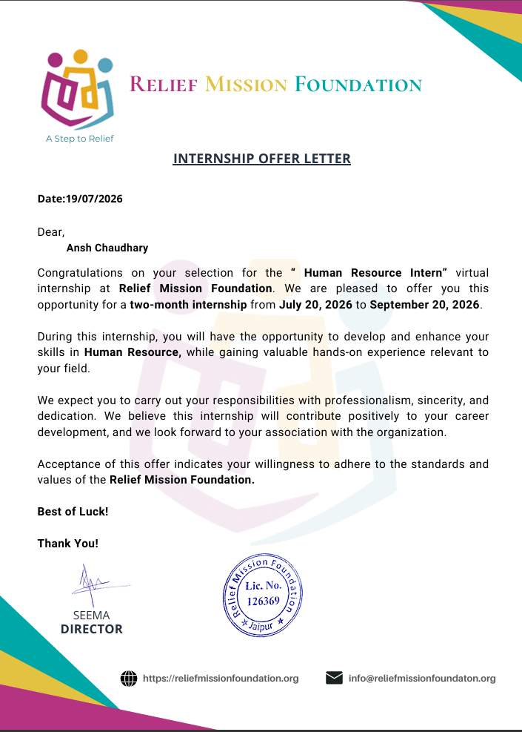

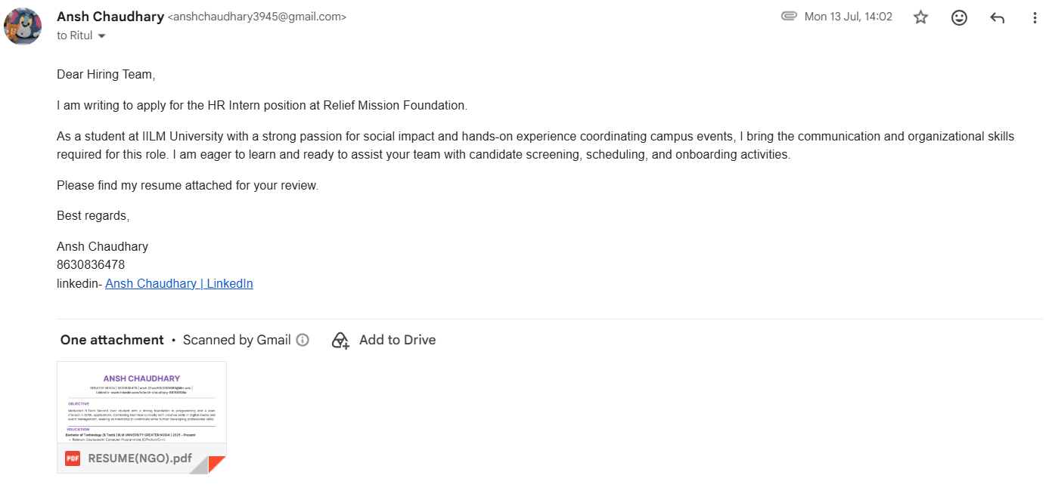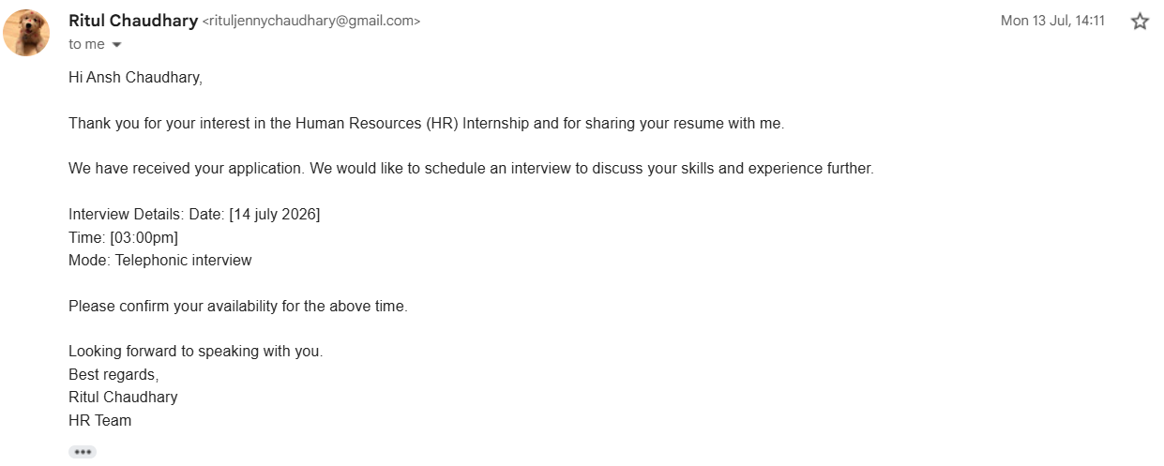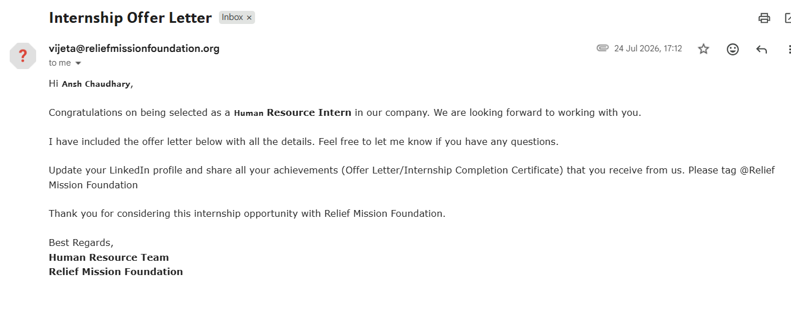

5. BIBLIOGRAPHY / REFERENCES
- Relief Mission Foundation. (2021). Certificate of Incorporation & Section 8 License (CIN: U85300RJ2021NPL075422, License No. 126369). Ministry of Corporate Affairs, Government of India.
- Relief Mission Foundation. (2026). Official LinkedIn Page & Internship Guidelines. Available at LinkedIn: "Relief Mission Foundation: Overview | LinkedIn".
- School of Computer Science and Engineering, IILM University. (2026–27). Internship Report Guidelines and Formatting Manual. Greater Noida, U.P
